Supplementary File 4.2 - sensitivity analysis

S2.1. Phase 1: One-at-a-time (OAT) screening
The OAT screening phase evaluated the influence of 13 model parameters on five output variables. Parameters were selected based on their biological relevance to disease transmission, clinical outcomes, and production performance (Table S1). Each parameter was varied to 80% and 120% of its baseline value while all other parameters remained at baseline. This design was implemented for each combination of:
- Four MDA distributions: A, B, C and D.
- Two vaccination scenarios: Vaccinated at 21 days of age vs. not vaccinated (NV).
Ten independent replicates were run for each scenario to account for stochastic variability.
Table S1. Parameters evaluated in the OAT sensitivity analysis.
Parameter | Baseline | Low / High
transmission_PCV2SD | 0.55 | 0.44 / 0.66
transmission_PCV2SI | 0.35 | 0.28 / 0.42
base_p_infection_PCV2SD | 0.10 | 0.08 / 0.12
lethality_PCV2SD | 0.0467 | 0.037 / 0.056
recovery_PCV2SD | 0.02 | 0.016 / 0.024
recovery_PCV2SI | 0.015 | 0.012 / 0.018
susceptibility_IMM_P | 0.005 | 0.004 / 0.006
default_proba_success_vacc | 0.95 | 0.76 / 1.14*
mda_waning | 0.015 | 0.012 / 0.018
reduction_adwg_PCV2SD_nursery | 0.04 | 0.032 / 0.048
reduction_adwg_PCV2SD_finishing | 0.08 | 0.064 / 0.096
reduction_adwg_PCV2SI_nursery | 0.02 | 0.016 / 0.024
reduction_adwg_PCV2SI_finishing | 0.04 | 0.032 / 0.048

S2.2. Phase 2: Full factorial design
Based on Phase 1 results, five parameters were identified as most influential and selected for factorial analysis (Table S2). The full 3⁵ factorial design (243 parameter combinations) was crossed with four MDA distributions and two vaccination scenarios, resulting in 1,944 unique scenarios. Each scenario was replicated 10 times, yielding 19,440 total simulations.

Table S2. Parameters and levels used in the factorial sensitivity analysis.
Parameter | Low | Base | High
default_proba_success_vacc | 0.80 | 0.95 | 0.99
base_p_infection_PCV2SD | 0.05 | 0.10 | 0.15
mda_waning | 0.010 | 0.015 | 0.020
reduction_adwg_PCV2SD_finishing | 0.04 | 0.08 | 0.12
transmission_PCV2SI | 0.25 | 0.35 | 0.45

S2.3. Statistical analysis
For each output variable o, a linear regression model was fitted including main effects and first-order interactions:
Yₒ = β₀ + Σᵢ βᵢXᵢ + Σᵢ<ⱼ βᵢⱼXᵢXⱼ + ε
The contribution of parameter p to output variance was calculated as:
Cₚ = (SSₚ + Σₚ' SSₚ:ₚ') / SSₜₒₜₐₗ
where SSₚ is the sum of squares for the main effect of parameter p, SSₚ:ₚ' is the sum of squares for the interaction between parameters p and p', and SSₜₒₜₐₗ is the total sum of squares. Type II ANOVA was used to ensure appropriate handling of unbalanced designs.

S2.4. Results
S2.4.1. Phase 1: OAT screening results
The OAT analysis identified distinct patterns of parameter influence depending on vaccination status and MDA distribution (Figure S1). In NV scenarios, base infection probability (base_p_infection_PCV2SD) consistently explained the largest proportion of variance in disease outcomes. For production parameters, ADWG reduction during finishing (reduction_adwg_PCV2SI_finishing) and MDA waning rate (mda_waning) were most influential. In vaccinated scenarios, vaccine efficacy (default_proba_success_vacc) dominated across all outputs, with MDA waning rate showing increased importance in the distribution A.
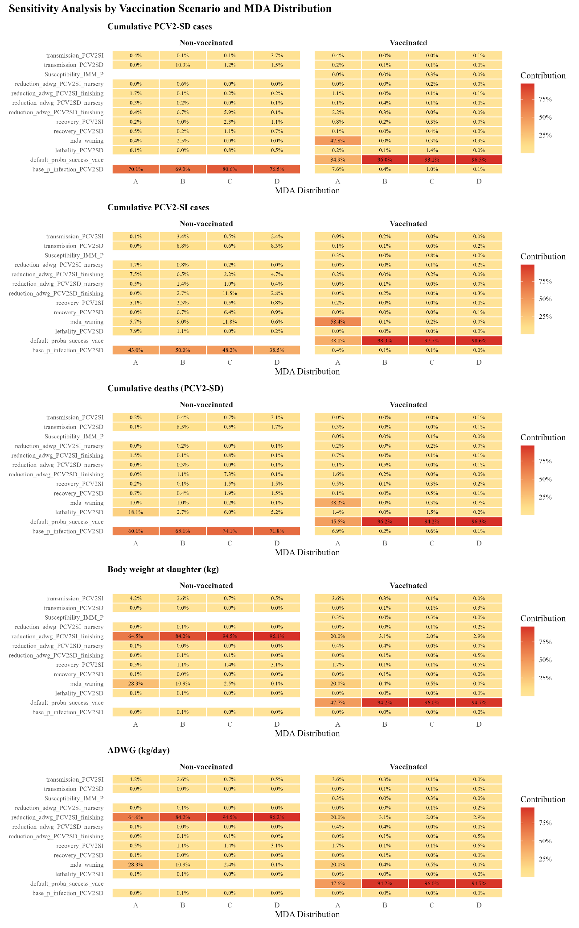
Figure S1. Parameter contribution to output variance in the one-at-a-time (OAT) sensitivity analysis. Heatmaps show the percentage of variance explained by each parameter for five model outputs: cumulative PCV2-SD cases, cumulative PCV2-SI cases, cumulative deaths due to PCV2-SD, body weight at slaughter, and average daily weight gain (ADWG). Results are stratified by vaccination status (non-vaccinated vs. vaccinated at 21 days) and maternal antibody (MDA) distribution (A-D). Each parameter was varied ±20% from its baseline value. Colour intensity reflects the magnitude of contribution, with darker shades indicating higher influence on output variance.
S2.4.2. Phase 2: Factorial analysis results
The factorial analysis confirmed and refined the OAT findings (Figure S2 and Table S3). Key results by vaccination status are:
- Non-vaccinated scenarios:
  - Cumulative PCV2-SD cases: Base infection probability (base_p_infection_PCV2SD)
  - Cumulative PCV2-SI cases: Base infection probability (base_p_infection_PCV2SD)
  - Mortality by PCV2-SD: Base infection probability (base_p_infection_PCV2SD)
  - Body weight: MDA waning rate (mda_waning)
  - ADWG: MDA waning rate (mda_waning)
- Vaccinated scenarios:
  - All disease outputs: Vaccine efficacy (default_proba_success_vacc)
  - Production outputs: Vaccine efficacy (default_proba_success_vacc)
  - Exception with the distribution A: MDA waning rate (mda_waning) contributed 40-72% to production outputs.
Table S3. Summary of dominant parameters by output and vaccination status.
Output | Non-vaccinated | Vaccinated*
Cumulative PCV2-SD cases | base_p_infection_PCV2SD (98-99%) | default_proba_success_vacc (84-85%)
Cumulative PCV2-SI cases | base_p_infection_PCV2SD (68-93%) | default_proba_success_vacc (97-98%)
PCV2-SD cumulative deaths | base_p_infection_PCV2SD (92-99%) | default_proba_success_vacc (82-85%)
Body weight at slaughter | mda_waning (81-89%) | default_proba_success_vacc (92-97%)
ADWG | mda_waning (81-88%) | default_proba_success_vacc (92-97%)
*Except distribution A, where MDA waning rate contributed 40-72%

S2.4.3. Parameter interactions
First-order interactions between parameters were evaluated in the factorial analysis (Figure S3). Main effects dominated across all outputs, with base infection probability explaining up to 20% of variance for disease-related outcomes and MDA waning rate contributing up to 1% for production parameters. No interaction contributed more than 0.1% to output variance. The only marginally detectable interaction was between MDA waning rate and transmission SI for production outcomes. The negligible contribution of interactions indicates that parameter effects are predominantly additive.
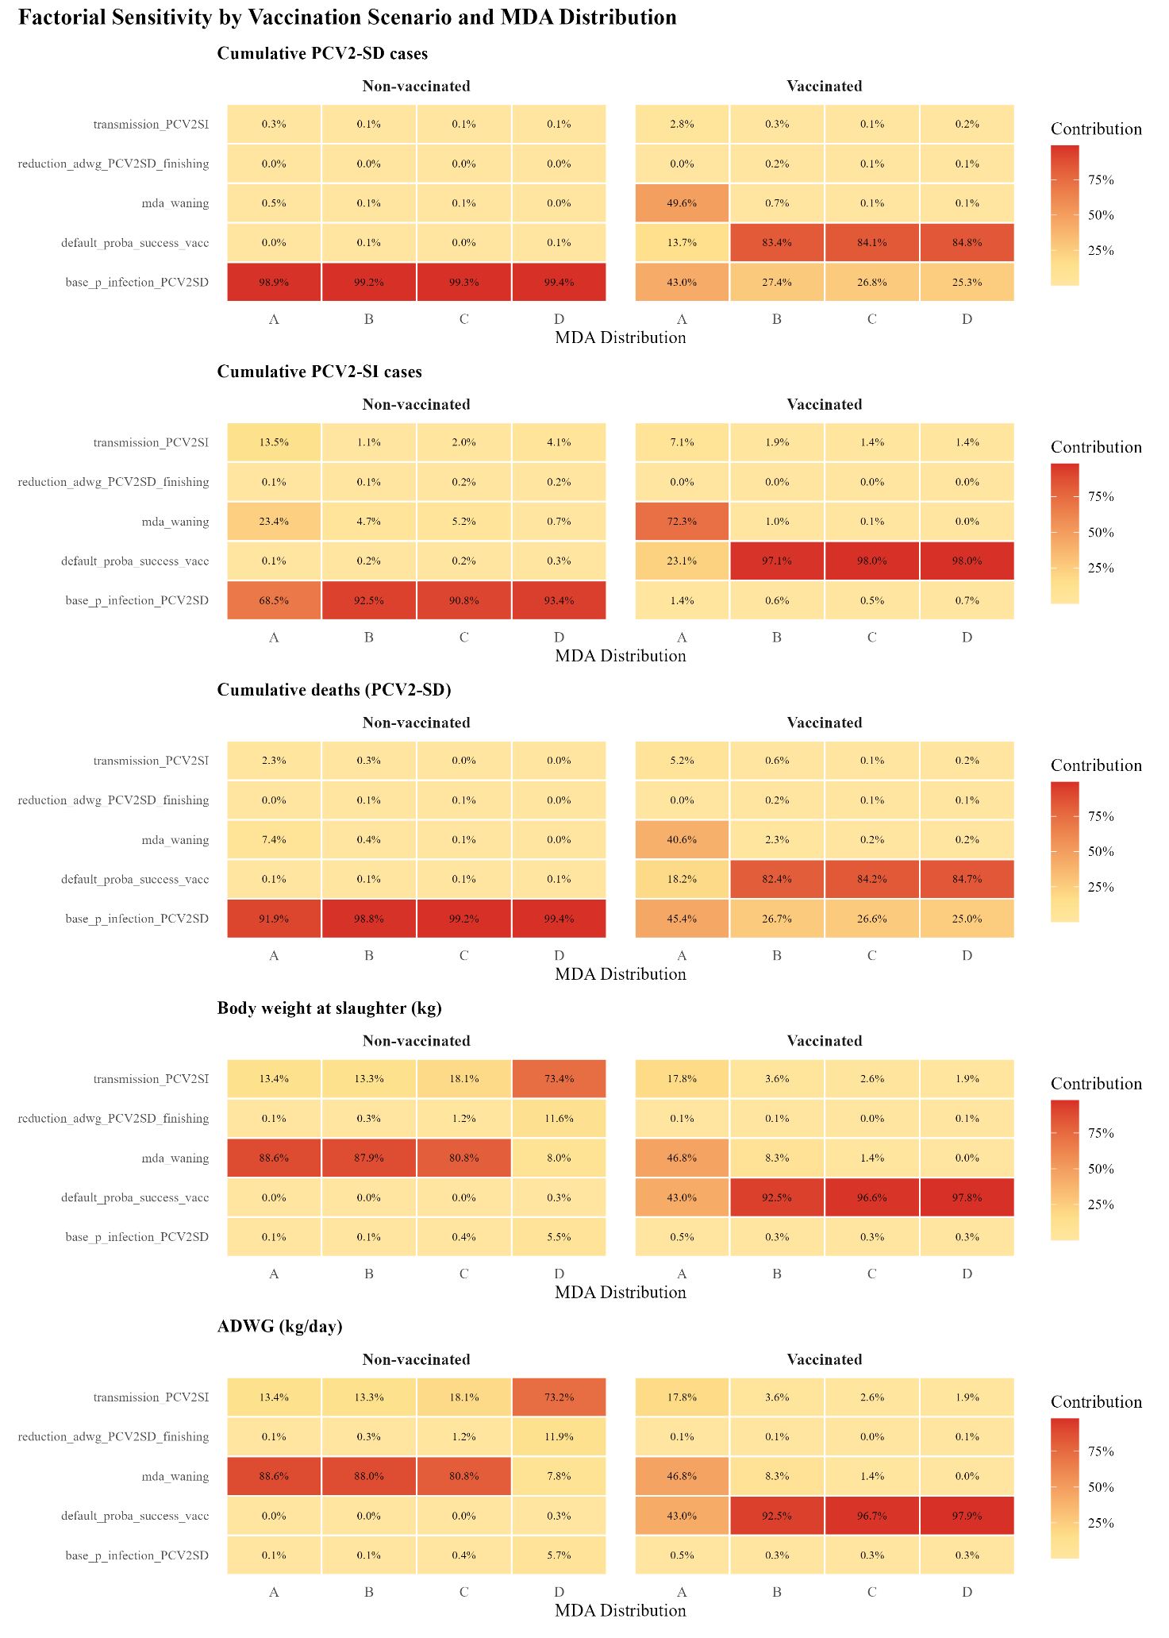
Figure S2. Parameter contribution to output variance in the factorial sensitivity analysis. Heatmaps display the percentage of variance explained by the five parameters selected from Phase 1 screening: vaccine efficacy, transmission rate (PCV2-SI), MDA waning rate, base infection probability, and ADWG reduction during finishing (PCV2-SD). Results are presented for five model outputs stratified by vaccination status and MDA distribution (A–D). The factorial design included three levels per parameter (low, baseline, high), enabling estimation of main effects and first-order interactions. Values represent total parameter contribution (main effect plus associated interactions).
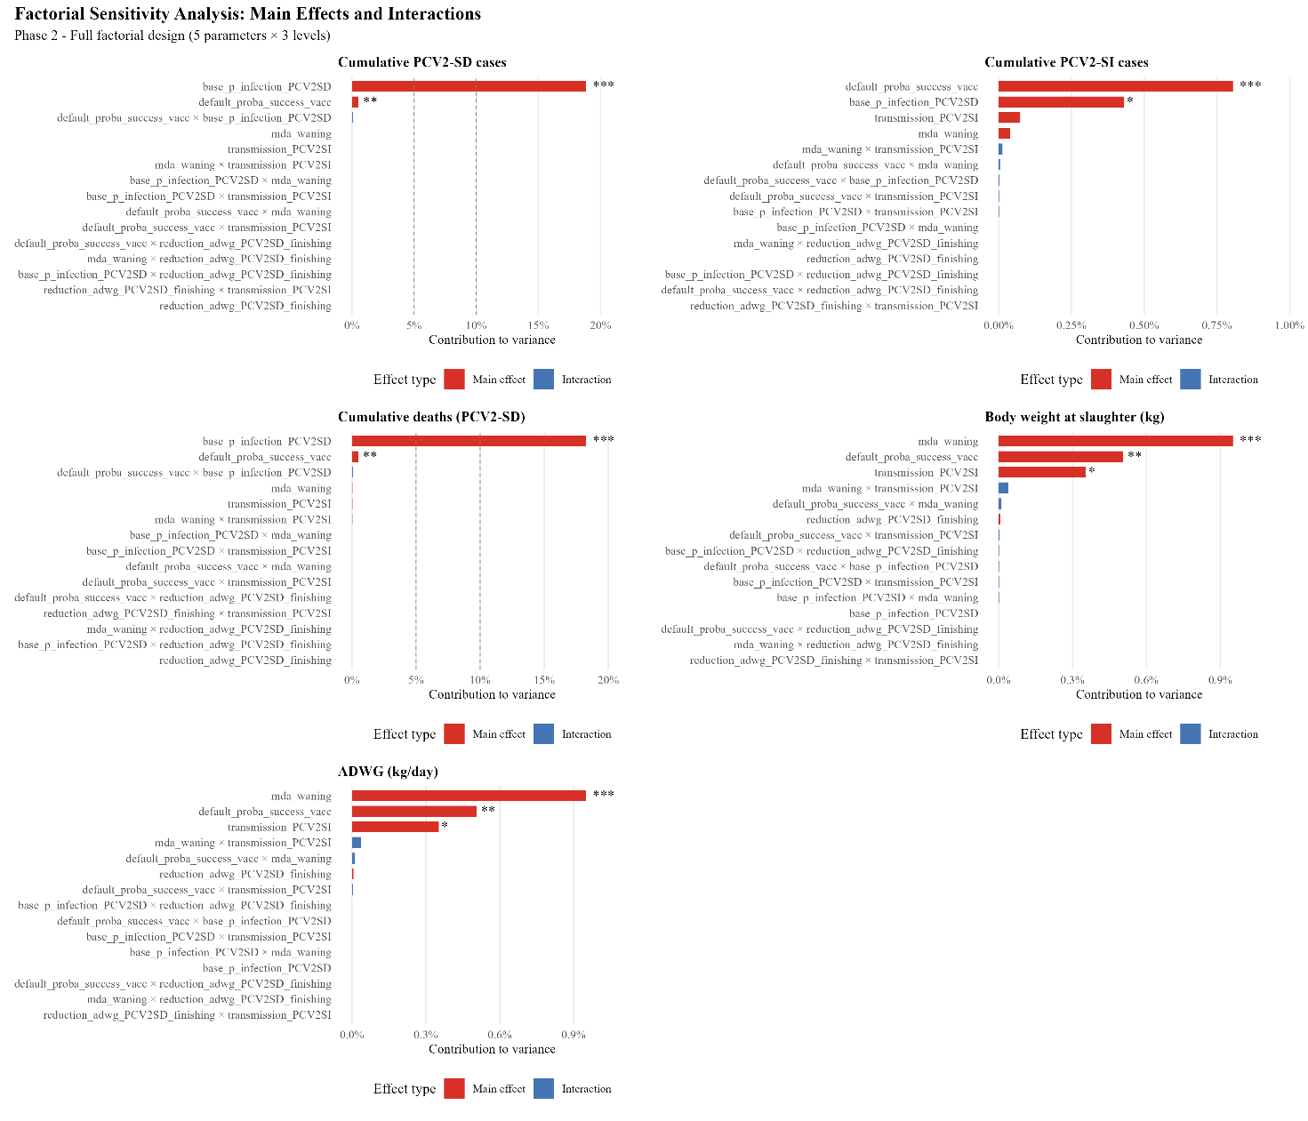
Figure S3. Main effects and first-order interactions in the factorial sensitivity analysis. Tornado plots show the contribution of each effect to output variance, ranked in descending order. Red bars indicate main effects; blue bars indicate pairwise interactions. Asterisks denote statistical significance (*p < 0.05, **p < 0.01, ***p < 0.001). Results are from the global analysis combining all vaccination scenarios and MDA distributions. The dominance of main effects and negligible interaction contributions (<0.1%) indicate that parameter effects are predominantly additive.

